Design Document;

The chosen period/theme of the game was including renaissance theme, so most design aspects of the game will be influenced by this.

**Subjects I will discuss.**

* NPC’s.

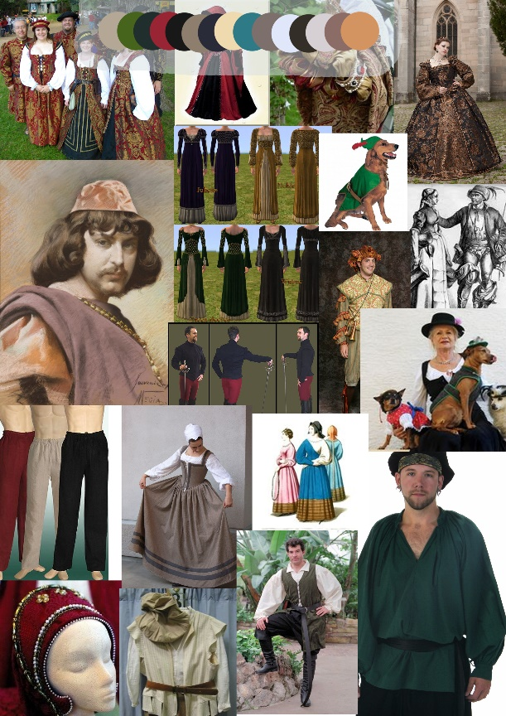To find what clothes the characters in our renaissance themed game where wearing and what kind of colors their outfits where, I constructed a mood board of outfits, hairstyles characters and other images relevant to establishing the NPC’s design.

The clothes and animals in this mood board helped inspire ideas for jobs, creatures, companions and the clothes they will all wear.

* Overworld/Terrain.

I also made a mood board of renaissance buildings and terrain such as farmland and mountains to construct an overworld around that the player would then establish his colony in.

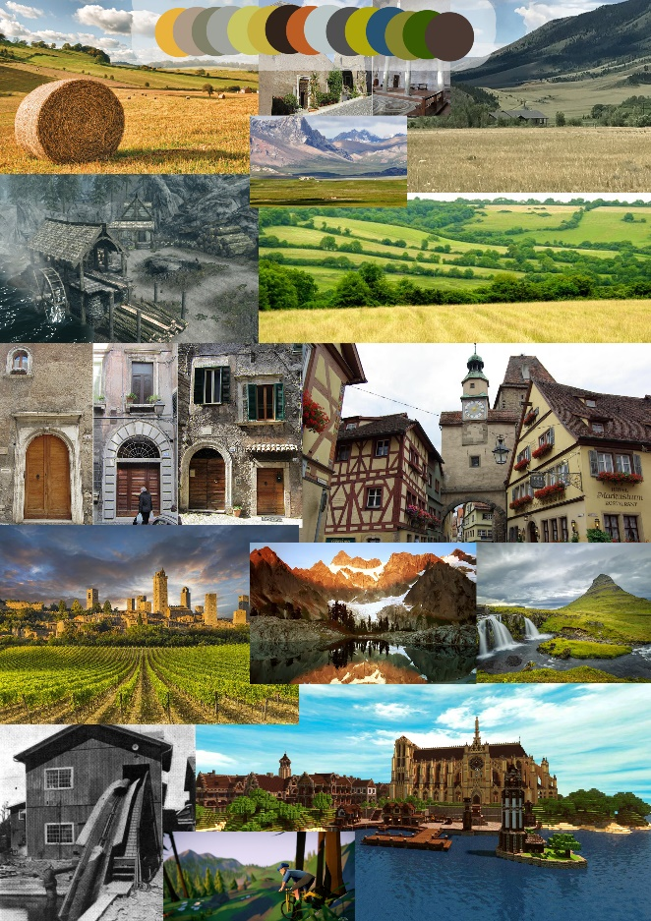

As you can see from the mood board I will be using a lot of terrain such as fields and forest surrounded by mountains and rivers as a form of gating (which I will talk about later), the buildings on the mood board that I had chosen where to simply demonstrate the architecture and structures used as I will not be making the buildings although I want to use them as grounding to then see how they would be implemented into the overworld.

The overworld will be mainly fields and forests with mountains around the outskirts and water around further outskirts, waterfalls and ponds will also be included and different grasslands depending on its purpose.

* Enemies/Creatures.

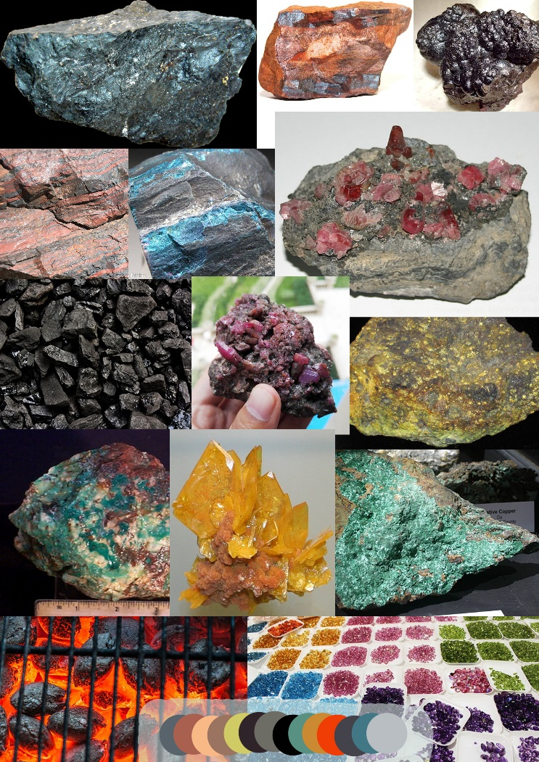Like the mood board for the NPC’s I used it to establish what monsters/dinosaurs I could potentially use, taking notes on them to put them with the correct resources that would suit theme and design. The mood board below has all the resources and dinosaurs I could potentially use to help build the games eco-system.

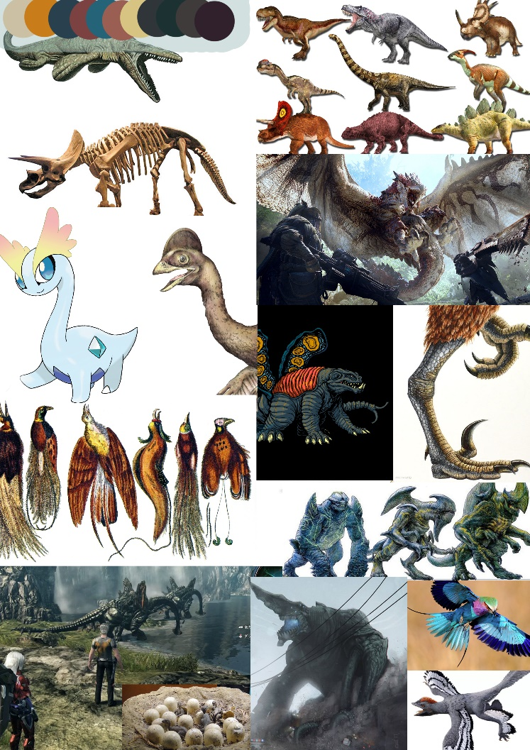

* Color Palettes.

Each mood board contains an isolated color palette of the most common colors to help me establish what colors each character, monster, building and even terrain should have.

* Gating.

An idea I came up for the game which I wanted to briefly mention in the design document is the concept of gating via of the terrain of the map, such as making bridges to advance over rivers or digging through mountains.

**Resource Design.**

I was given the task to establish the resources we are going to use in our game, what loops they ay have and what they would do for example, how if we were to use wood in our game, what purposes would it have to benefit the player and what resource would it be.

I will use the mood board I had created earlier showing some resources you would mine and gather, on top of some more research to help establish this.

I researched into a basic list of human needs to use as a footing for the resources our colony would need.

* Water.
* Food.
* Shelter.
* Sleep.
* Oxygen.

From (<http://www.brighthub.com/environment/science-environmental/articles/123273.aspx>)

This website gave some obvious resources that the game will need, of course there will be oxygen in the game world and it will not have to be obvious, but the players will need to gather resources to make shelter, this would also be used for the buildings they construct like the granary and blacksmiths forge.

Considering several websites that describe the building resources you need for a house all specify you need lumber and stone. Although this seems obvious it was important to include.

So now we know that that colony needs buildings for sleep and shelter, so they need lumber, stone, water and food such as meat and vegetables. But how will the player get the food. As most colonies do they hunt and gather for their food, we had already established we will go out and hunt for most of our resources so now I must find out what resources the player will need to hunt, since I already know we will use wood and stone to build, we can also use them for tools such as spears and bows.

As a way of showing progression in the game we will use metals as an advance resource to make tools and shelters out of, for example tools made from metal will help the hunter NPS’s to hunt creatures faster and more efficiently. And you can use those metals to make more advanced buildings that add new features to the colony’s.

Another of way of showing progression will be to have two metals, one that is more optimal and is cost effective, but you obtain later in the game to show the progression, this metal can also be used to make other buildings that you would not be able to make otherwise. Using and affordance that most people know of iron being better than bronze, bronze and iron will be the two metals that we use. We will also have two woods of oak and mahogany to show progression, mahogany being the higher progress resource.

We will use two diverse types of food of meat and fruit/Vegetables we will add them together into one name known as “nutrition” so nutrition will be the name of the food resource and even though it may be made of multiple resources it is under one name.

List of resources that will be in the game;

* Wood
* Bone
* Stone
* Bronze
* Iron
* Water
* Meat (nutrition)
* Vegetables/Fruit (nutrition)

Using the gating we as a team had planned to use before, we will gate off the better resources for metal and wood (iron and mahogany) and once the players have crossed the gating they will then have access to these new materials.